
PROJECT REPORT ON
“INDIANPULSE – ECONOMIC DASHBOARD”

Team Members
Name | PRN | Roll No.
Kunal Tailor | 1032233258 | 47
Rishav Singh | 1032233012 | 39
Anuj Kudu | 1032233203 | 45
Yash Pathrikar | 1032233341 | 51

Guide Name
Dr. Prashant Lahane

ACKNOWLEDGMENT
We would like to express our sincere gratitude to our project guide, Dr. Prashant Lahane, for their continuous guidance, valuable suggestions, and constant encouragement throughout the development of this project. Their expertise and insights were instrumental in shaping this work.
We are deeply thankful to the Head of the Department and all faculty members of the Department of Computer Science and Engineering for their unwavering support, constructive feedback, and motivation that helped us overcome various challenges during the project lifecycle.
Our appreciation extends to the open-source communities of Flask, Chart.js, Pandas, Bootstrap, and NumPy, whose exceptional libraries and comprehensive documentation made this project feasible and efficient.
We acknowledge the data sources including Reserve Bank of India (RBI), Ministry of Statistics and Programme Implementation (MOSPI), CBIC, CMIE, NPCI, and OECD for maintaining publicly accessible economic datasets that form the backbone of this dashboard.
A special thanks to our families and friends for their patience, encouragement, and moral support throughout this journey. Their belief in our capabilities kept us motivated during challenging phases of development.
Finally, we acknowledge the spirit of Digital India and Open Data movements that inspired this project and align with our vision of making economic information accessible to all.

ABSTRACT
IndianPulse is an innovative, interactive, data-driven economic dashboard specifically designed for visualizing India's macroeconomic landscape. The platform leverages modern web technologies including Flask (Python) for robust backend operations and HTML5/CSS3/JavaScript with Chart.js for dynamic, responsive frontend visualizations.
The system aggregates and visualizes 13+ key economic indicators including GDP Growth Rate, Consumer Price Index (CPI), GST Collections, Trade Balance, Unemployment Rate, Foreign Exchange Reserves, Digital Payment Transactions, Repo Rate, Index of Industrial Production (IIP), Financial Inclusion Index, Composite Leading Indicator, Stock Market Performance (Nifty 50), and Agriculture Output Index.
Technical Architecture:
The dashboard employs a modular two-tier client-server architecture where the Flask backend serves as the API layer, handling data processing, transformation, and delivery via RESTful endpoints. The frontend utilizes Chart.js 4.x for rendering dynamic visualizations including line charts, bar graphs, area charts, scatter plots, radar charts, and mixed-type visualizations. Data processing is powered by Pandas and NumPy for efficient manipulation of large datasets, with SQLite/MySQL providing structured data persistence.
Data Integration:
Economic data is sourced from authoritative institutions: RBI (monetary policy data), MOSPI (inflation, industrial production), CBIC (taxation data), CMIE (employment statistics), NPCI (digital payment metrics), OECD (leading indicators), NSE (market data), and Ministry of Agriculture (agricultural output).
Key Features:
- Real-time data fetching and visualization
- Interactive charts with zoom, pan, and tooltip features
- Comparative analysis between multiple indicators
- Time-series analysis with customizable date ranges
- Data export functionality (CSV, JSON, PNG)
- Responsive design with dark/light theme toggle
- Caching mechanism for performance optimization
- Mobile-first design approach
Impact and Significance:
In an era of data-driven governance and digital transformation, IndianPulse bridges the gap between complex, scattered economic datasets and actionable visual insights. It democratizes access to economic information, enabling policymakers, researchers, business analysts, students, and informed citizens to understand India's economic trajectory at a glance.
The platform aligns with the Digital India initiative and promotes transparency in economic data dissemination, fostering a data-literate society capable of making informed decisions based on factual economic trends.

TABLE OF CONTENTS

- Problem Statement
- Scope of the Project
- Introduction
- Literature Review
- System Requirements
- System Design and Architecture
- Implementation and Methodology
- Data Sources and Indicators
- Results and Analysis
- Real-World Applications
- Challenges and Solutions
- Future Scope and Enhancements
- Conclusion
- References

CHAPTER 1: PROBLEM STATEMENT
Economic data in India is scattered across multiple government and institutional platforms, often presented in static or unstructured formats. This fragmentation makes it difficult for researchers, policymakers, and citizens to interpret trends and correlations among indicators such as GDP, inflation, or trade balance.
Problem:
There is no unified, interactive platform that combines these economic datasets into a single dashboard, offering real-time visualization and comparative insights.

CHAPTER 2: SCOPE OF THE PROJECT
The project aims to:
- Consolidate major economic datasets into a single, accessible dashboard.
- Enable dynamic visual comparisons of indicators.
- Facilitate research and decision-making through visual analytics.
- Promote open-data usage and transparency in economic analysis.
Limitations:
The dashboard focuses on national-level data; predictive analytics and state-level insights are planned for future versions.

CHAPTER 3: INTRODUCTION
India’s economy is among the fastest-growing in the world, and understanding its trends is vital for governance, businesses, and academia. However, official data is scattered across multiple platforms, often in tabular or PDF formats that are hard to interpret quickly.
IndianPulse resolves this issue by offering a unified dashboard that integrates multiple indicators like GDP, Inflation, Unemployment, Forex, GST, and Trade Balance in a single interactive platform.
It provides:
- Comparative visualization between key indicators.
- Real-time data processing and rendering.
- Dynamic chart updates and trend analysis.
Objectives:
- To consolidate various economic datasets into one unified dashboard.
- To visualize trends and correlations between indicators.
- To assist researchers, policymakers, and students in economic analysis.
- To promote open data accessibility and transparency.
The motivation arises from the Digital India initiative and the growing importance of data transparency for policy and business intelligence.

CHAPTER 4: LITERATURE REVIEW
Existing research and dashboards (like TradingEconomics, World Bank Data Portal, and CMIE Consumer Pyramids) provide macroeconomic analysis but lack:
- Granular India-focused data integration.
- Real-time visualization tailored to Indian datasets.
- Open-source and free accessibility.
Studies such as “Economic Visualization using Interactive Dashboards” (IEEE, 2022) emphasize that visual analytics enhances user understanding and promotes engagement with large datasets.
Dashboards built with Flask and Chart.js are efficient due to their lightweight nature and RESTful integration capabilities.
IndianPulse builds upon these findings by combining open-source tools, Indian economic datasets, and modern web technologies to deliver an accessible and educational visualization platform.

CHAPTER 5: SYSTEM REQUIREMENTS
Hardware:
- Processor: Intel i5 or above
- RAM: 8 GB minimum
- Storage: 1 GB
- Display: 1080p
Software:
- OS: Windows / Linux / macOS
- Python 3.10+
- Flask, Pandas, NumPy
- Chart.js, Bootstrap
- SQLite/MySQL

CHAPTER 6: SYSTEM DESIGN AND ARCHITECTURE
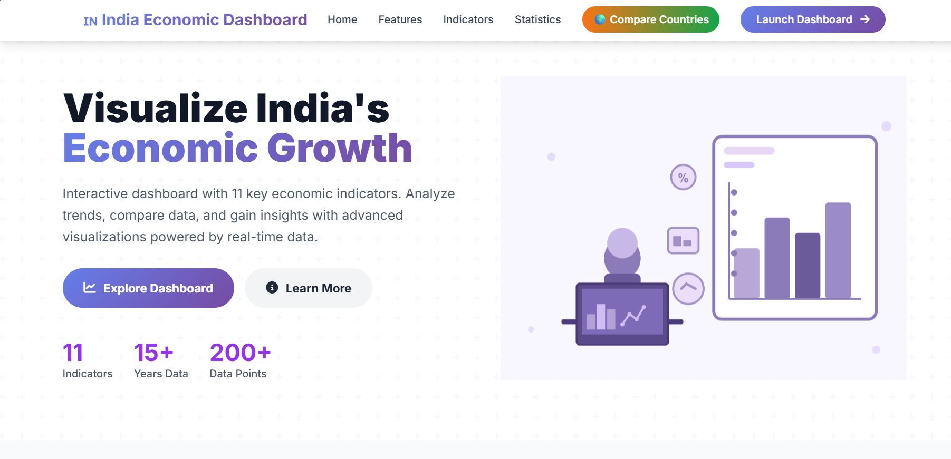
IndianPulse follows a two-tier client-server model:
Frontend:
- Built using HTML, CSS, Bootstrap, and JavaScript.
- Uses Chart.js for real-time data visualization.
- Responsive design with light/dark theme toggle.
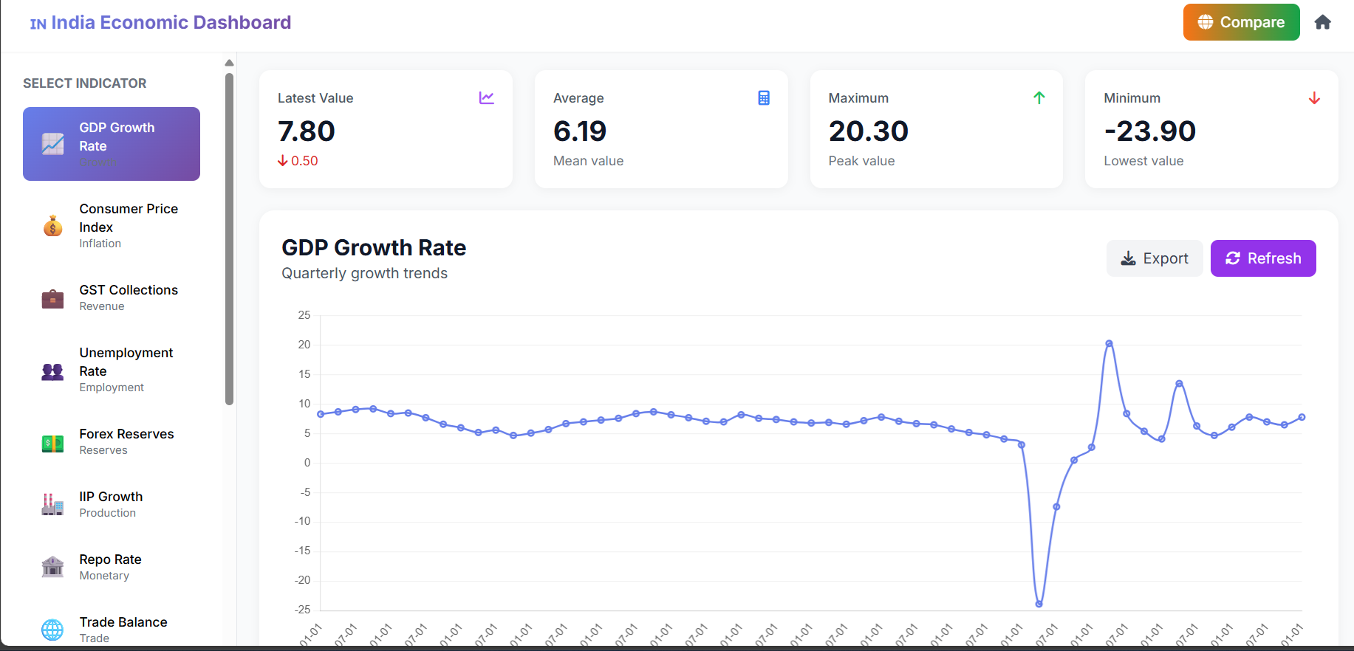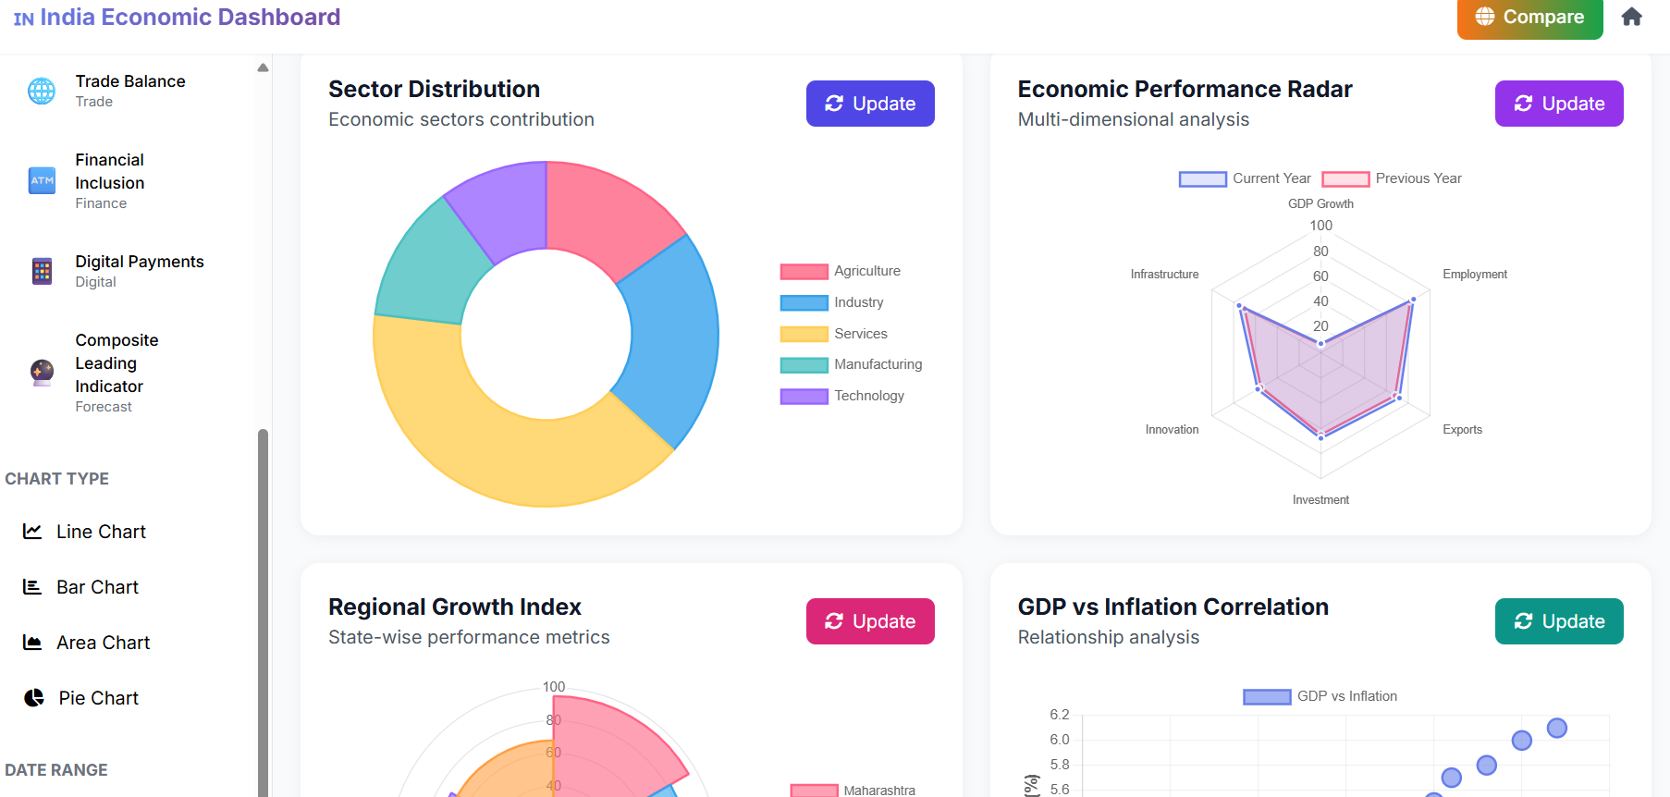
Backend:
- Powered by Flask (Python) for REST API management.
- Uses Pandas for data cleaning, transformation, and filtering.
- Integrates with SQLite/MySQL for structured data storage.
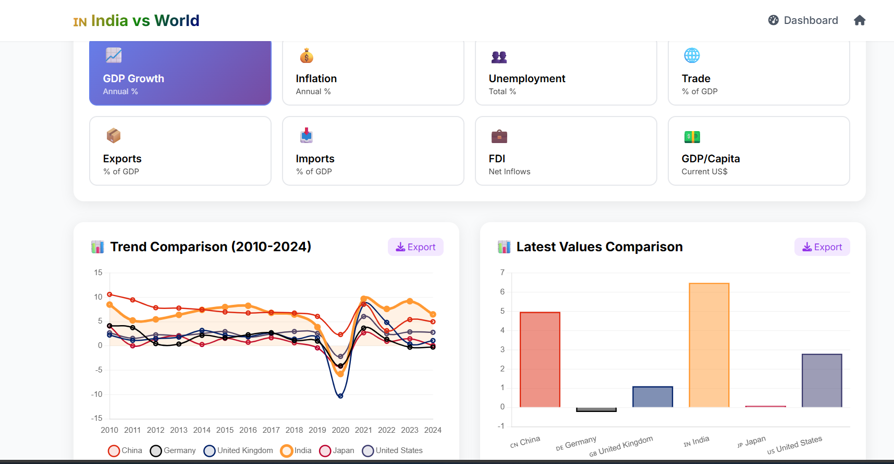

Workflow
- User selects an indicator or time period.
- Frontend sends AJAX request to Flask API.
- Flask processes data (e.g., monthly GDP, inflation).
- Returns data as JSON response.
- Chart.js visualizes it dynamically.
Additional Components:
- Caching layer using Flask-Caching for performance.
- Export options for downloading charts as images or CSV.
- Mobile-optimized UI for accessibility.
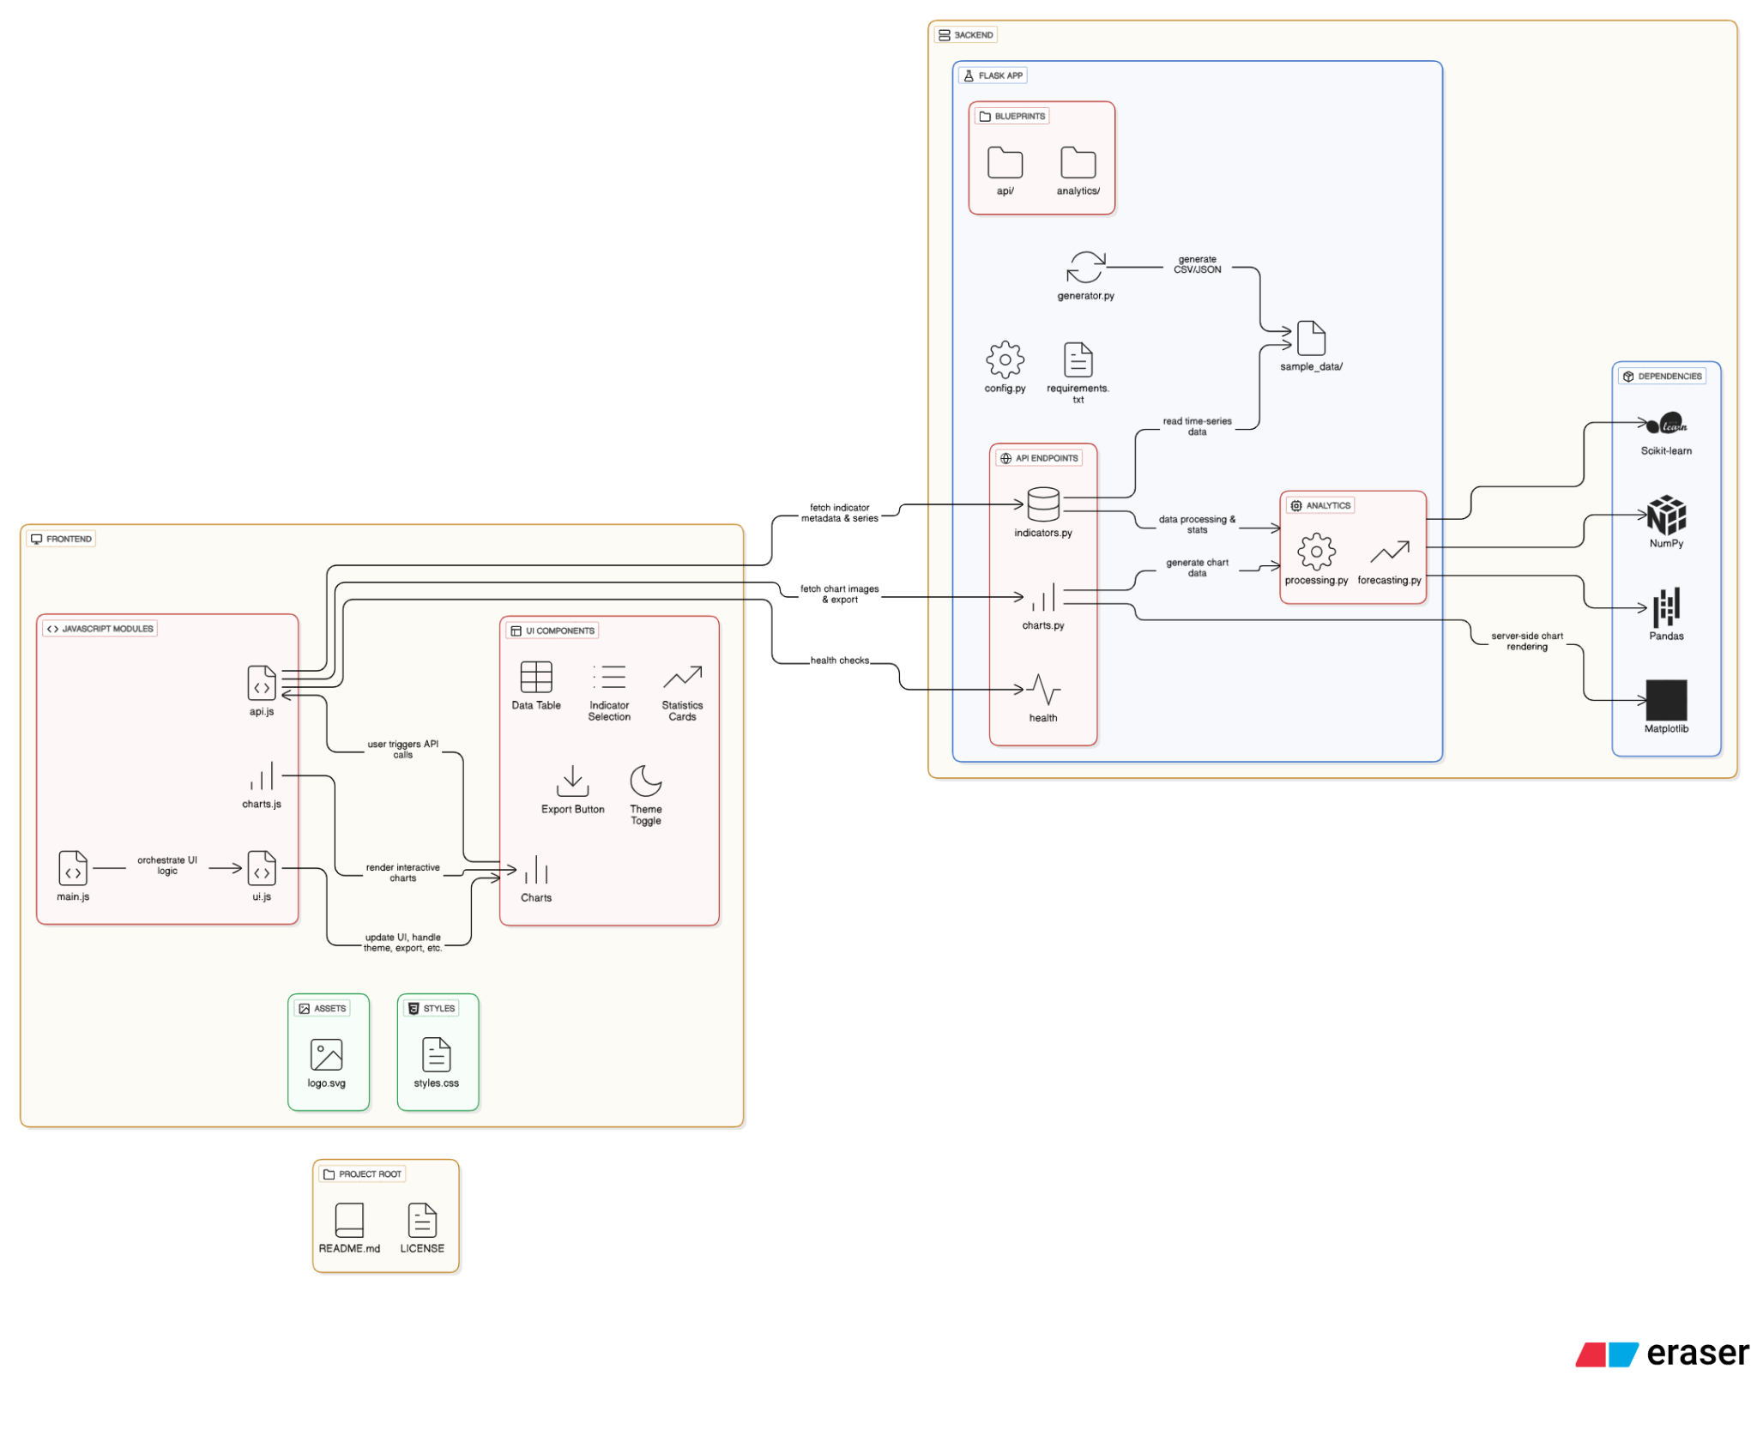

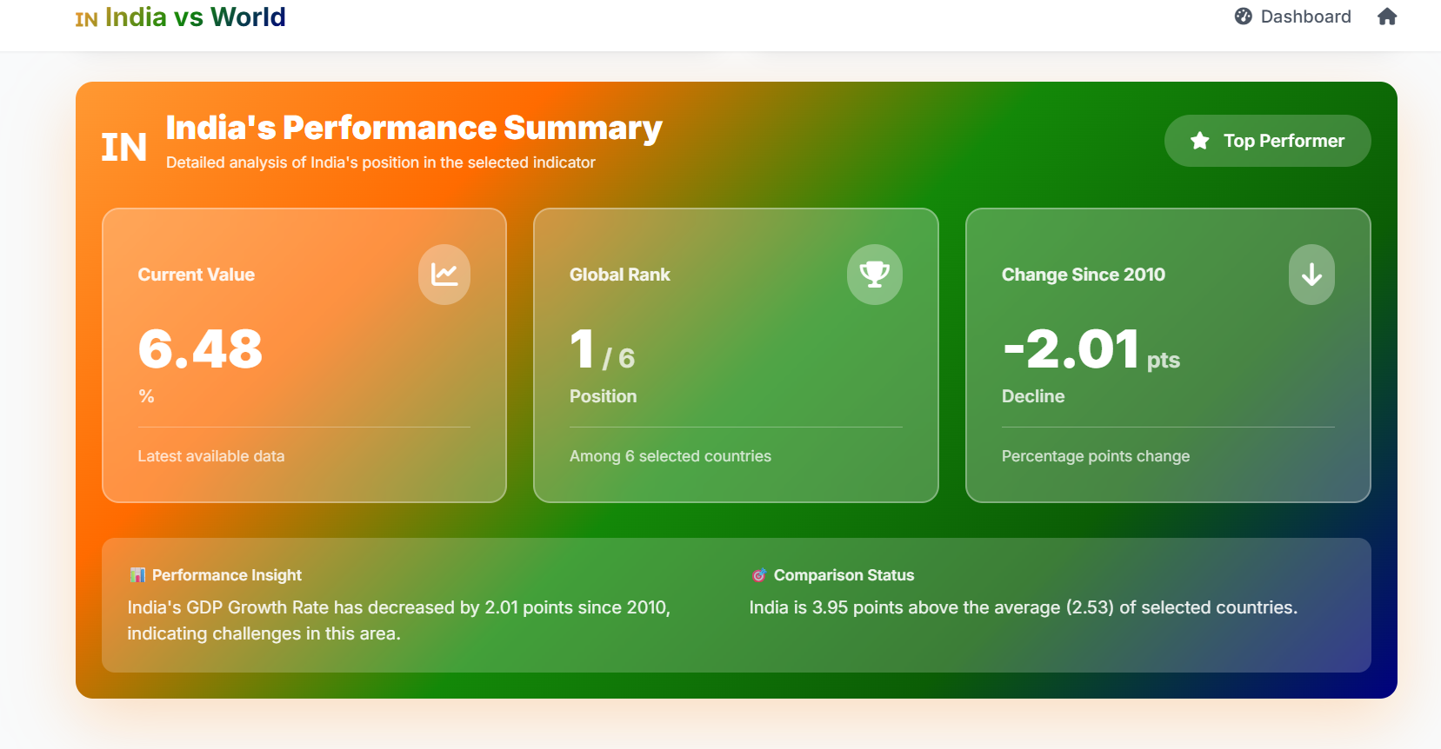

CHAPTER 7: IMPLEMENTATION AND METHODOLOGY
The development followed an incremental and modular approach:
- Data Collection and Cleaning:
  - Used Pandas for handling CSV and Excel datasets.
  - Null values, duplicates, and inconsistent entries were cleaned.
- API Development:
  - Flask routes created for each indicator (e.g., /api/gdp, /api/inflation).
  - Implemented cross-origin support using Flask-CORS.
- Frontend Integration:
  - JavaScript fetches JSON data asynchronously.
  - Chart.js dynamically renders interactive visualizations.
  - Bootstrap used for layout consistency.
- Testing and Validation:
  - Unit testing with pytest.
  - Frontend validation using sample datasets.
Tools and Libraries Used:
- Flask, Pandas, NumPy, Chart.js, Bootstrap, Matplotlib (for backend visualization).
- SQLite/MySQL database for structured storage.

CHAPTER 8: DATA SOURCES AND INDICATORS EXPLANATION

Indicator | Description | Unit | Frequency | Source
GDP Growth Rate | Quarterly GDP growth rate | % | Quarterly | RBI
Consumer Price Index | Monthly inflation measure | Index | Monthly | MOSPI
GST Collections | Monthly tax revenue | ₹ Crores | Monthly | CBIC
Unemployment Rate | Labour force joblessness | % | Monthly | CMIE
Forex Reserves | Total foreign reserves | USD Billion | Weekly | RBI
Index of Industrial Production | Manufacturing & Mining growth | Index | Monthly | MOSPI
Repo Rate | Monetary policy rate | % | Monthly | RBI
Trade Balance | Imports vs Exports | USD Million | Monthly | DGCI&S
Financial Inclusion Index | Access to banking & digital services | Index | Quarterly | RBI
Digital Payment Volume | UPI, IMPS, and NEFT transactions | ₹ Crores | Monthly | NPCI
Composite Leading Indicator | Predictive measure of economy | Index | Monthly | OECD
Stock Market Index (Nifty 50) | Market performance indicator | Index Points | Daily | NSE
Agriculture Output Index | Crop and rural productivity | Index | Quarterly | Ministry of Agriculture

CHAPTER 9: RESULTS AND ANALYSIS
The dashboard allows:
- Multi-indicator comparison.
- Interactive line and bar charts.
- Real-time updates through AJAX.

Examples:
- GDP Growth Visualization: Displays post-pandemic recovery trends.
- CPI vs Repo Rate: Shows the relationship between inflation and monetary policy.
- Trade Balance Chart: Highlights import-export dynamics and rupee stability.
- Digital Transactions: Demonstrates India’s fintech revolution post-UPI introduction.
Export options allow users to save visualizations as PNG, PDF, or CSV.
Data filtering and tooltips improve interpretability and user experience.

CHAPTER 10: REAL-WORLD APPLICATIONS AND USEFULNESS
For Policymakers:
Supports monetary and fiscal policy evaluation.
For Businesses:
Helps forecast market behavior based on macroeconomic indicators.
For Students & Researchers:
Provides structured datasets and visual insights for academic use.
For Citizens:
Promotes awareness of India’s economic position and trends.
Real-time access to economic indicators helps interpret practical questions such as:
- How does repo rate affect EMIs?
- How do GST collections reflect market activity?
- What is the inflation trend relative to growth rate?

CHAPTER 11: CHALLENGES AND SOLUTIONS

Challenge | Solution
Inconsistent formats across datasets | Used Pandas for data normalization
JSON load delays | Implemented Flask-Caching
Chart resizing and responsiveness | Used Bootstrap grid & Chart.js listeners
API errors during CORS | Used Flask-CORS middleware

CHAPTER 12: FUTURE SCOPE AND ENHANCEMENTS
Integration with live data APIs from RBI, MOSPI, and NPCI.
AI-based forecasting models using LSTM or ARIMA.
Expansion to include state-level indicators for localized analysis.
User accounts and personalized dashboards.
Integration with Power BI, Tableau, or Google Data Studio.
Deployment on cloud platforms like AWS or Azure for scalability.

CHAPTER 13: CONCLUSION
IndianPulse successfully demonstrates the importance of economic transparency and visualization in promoting informed decision-making.
Using Flask, Chart.js, and Pandas, it delivers an interactive experience that converts raw statistical data into meaningful insights.
The project aligns with India’s Digital Transformation goals and fosters a data-aware citizenry by making complex economic metrics visually intuitive and accessible.

CHAPTER 14: REFERENCES
- Reserve Bank of India (RBI) – https://rbi.org.in
- Ministry of Statistics and Programme Implementation (MOSPI) – https://www.mospi.gov.in
- Central Board of Indirect Taxes and Customs (CBIC) – https://www.cbic.gov.in
- Centre for Monitoring Indian Economy (CMIE) – https://www.cmie.com
- National Payments Corporation of India (NPCI) – https://www.npci.org.in
- Organisation for Economic Co-operation and Development (OECD) – https://data.oecd.org
- National Stock Exchange (NSE) – https://www.nseindia.com
- Ministry of Agriculture & Farmers Welfare – https://agricoop.gov.in
- TradingEconomics – Global Economic Indicators Database – https://tradingeconomics.com
- Kaggle Open Data Portals – https://www.kaggle.com/datasets
- Open Government Data (OGD) Platform India – https://data.gov.in
- World Bank Open Data – India Indicators – https://data.worldbank.org/country/india

